Normalization Exercise

1) Your task in this exercise is to move the un-normalized table to 3NF. To do this, use the dependency diagram.

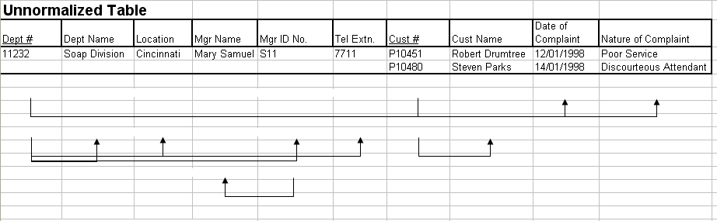

1NF

Dept# | Cust# | custName | Dept of complaint | Nature of complaint

Dept# | Dept Name | Location | Mgr Name | Mgr ID No. | Tel Extn

2NF
Dept# | Cust# | Dept of complaint | Nature of complaint

Dept# | Dept Name | Location | Mgr Name | Mgr ID No. | Tel Extn

Cust# | Cust Name.

3NF
Dept# | Cust# | Dept of complaint | Nature of complaint

Dept# | Dept Name | Location | Mgr ID No. | Tel Extn
Mgr ID No. | Mgr Name
Cust# | Cust Name.

2. Given the Tables Below, Match them with the normalized form (NOT in 1NF, 1NF, 2NF, 3NF, BCDNF, 4NF, 5NF) they are in:

 | TABLE A |  |  |  |  |  | TABLE B
PatID | Name | PhysID |  | PhysName |  | PatID | Name | PhysName
54321 | Gore, A. | 12345 |  | Scholl, F. |  | 54321 | Gore, A. | Scholl, F.
43210 | Bush, G. | 23456 |  | Seuss, M. |  | 43210 | Bush, G. | Seuss, M.
32109 | Cheney, J. | 34567 |  | Doolittle, J. |  | 32109 | Cheney, J. | Doolittle, J.
21098 | Clinton, H. | 45678 |  | Spock, L. |  | 21098 | Clinton, H. | Spock, L.
10987 | Nader, R. | 23456 |  | Seuss, M. |  | 10987 | Nader, R. | Seuss, M.

--------------------------------------------------------------- 1NF ------------------------------------------

 | TABLE C |  |  |  |  |  |  |  | TABLE D
PatID | Name | PhysID |  |  | PhysID | Name |  | PhysID |  | Name | PatID
54321 | Gore, A. | 12345 |  |  | 12345 | Scholl, F. |  | 12345 |  | Scholl, F. | 54321
43210 | Bush, G. | 23456 |  |  | 23456 | Seuss, M. |  | 12345 |  | Scholl, F. | 33445
32109 | Cheney, J. | 34567 |  |  | 34567 | Doolittle, J. |  | 12345 |  | Scholl, F. | 44556
21098 | Clinton, H. | 45678 |  |  | 45678 | Spock, L. |  | 23456 |  | Seuss, M. | 43210
10987 | Nader, R. | 23456 |  |  |  |  |  | 45678 |  | Spock, L. | 21098
 |  |  |  |  |  |  |  | 45678 |  | Spock, L. | 55667

--------------------------------------------------------------- 2NF ------------------------------------------

 | TABLE E |  |  |  |  |  |  | TABLE F
PatID | Name | PhysID |  | RX Need |  |  | PhysID |  | Name | Specialty
54321 | Gore, A. | 12345 |  | Podiatry |  |  | 12345 |  | Scholl, F. | Podiatry
43210 | Bush, G. | 23456 |  | Pediatrics |  |  | 23456 |  | Seuss, M. | Pediatrics
32109 | Cheney, J. | 34567 |  | Veterinary |  |  | 34567 |  | Doolittle, J. | Veterinary
21098 | Clinton, H. | 45678 |  | Hynosis |  |  | 45678 |  | Spock, L. | Hynosis
10987 | Nader, R. | 23456 |  | Pediatrics

--------------------------------------------------------------- 3NF ------------------------------------------

Employee and Projects
The table below depicts the requirements for a business consultancy working on local and international projects.
Emp-No | Emp-Name | Dept | Dept Manager | Proj-id | Proj-Start-Date | Location | Weeks-on-Project
005 | Smith | Marketing | Jones | A  B  C | 12-93  06-94  09-94 | Poole  Plymouth  Portsmouth | 11  15  6
007 | Bond | Accounts | Bloggs | B  D | 06-94  06-94 | Plymouth  Berlin | 3  9
009 | King | Info Systems | Hurne | C | 09-94 | Portsmouth | 10
010 | Holt | Accounts | Bloggs | A  B  D | 12-93  06-94  06-94 | Poole  Belfast  Hamburg | 21  10  12
Emp.no is the primary key. Employees work on a number of projects concurrently. Weeks-on-project represents the number of weeks that an employee has spent on a particular. The employee number, emp-no, and the project identifier, project-id, are unique identifiers. The department manager, manager, is the name of the current manager, i.e., there can be only one manager per department. A project can take place in several locations (i.e Employees can work on a project from their location). You are required to show the first, second and third normal forms.
1NF
Emp-No | Emp-Name | Dept | Dept Mang

Emp-No | Proj-id | Proj-Start-Date | Location | Weeks-on-Proj

2NF

Emp-No | Proj-id | Proj-Start-Date | Location | Weeks-on-Proj

Emp-No | Dept | Dept Mang

Emp-No | Emp-Name

3NF
Emp-No | Proj-id | Proj-Start-Date | Location | Weeks-on-Proj

Emp-No | Emp-Name

Emp-No | Dept

Emp-No | Dept Mang

